Michael Martin

M1A1

Initial values:

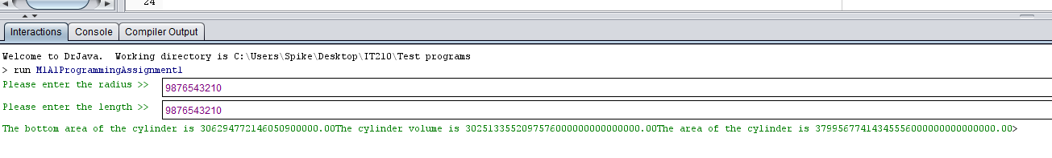

Bottom area:



Cylinder volume:



Cylinder Area:



In this assignment I created a program that measured the bottom area of a cylinder, cylinder volume, and area of a cylinder. I used Appendix C to help me limit my output values to two decimal places. I found with very large values, even using doubles I was unable to keep it to two decimal places. Although I do not like the output layout, I found the System.out.printf() to be the best option at my current knowledge level.

Farrell, J. (2016). Java programming (8th ed.). Boston, MA: Cengage Learning.